Interface Control Document (ICD): Payload to Bus
Revision: B
Date: 2025-11-17
Prepared By: Communications/Software Lead (Avrey)
Reviewed By:

1. Interface Overview
This ICD defines the electrical, mechanical, thermal, and data interfaces between the Payload Subsystem (RILA dosimeter, ZES board, magnetometer, and accelerometer) and the On-Board Computer (OBC) of the Sentinel Bio+ CubeSat. The document ensures proper physical mounting, power compatibility, signal format, and data flow between the payload and the bus.

2. Subsystem Overview
Component / Script Name | Description | Primary Function
RILA Dosimeter | Radiation dosimeter with onboard memory | Capture radiation exposure readings
ZES Board | Electronics support board | Interfaces RILA and sensors to OBC
Magnetometer | Magnetic field sensing | Part of science data payload
Accelerometer | Movement/orientation sensing | Science data for bio-exposure modeling
OBC Interface Board | Interface connector to CubeSat bus | Provides power and command/data handling

3. Electrical Interfaces

Component | Power Requirement | Connector Type | OBC Supply Voltage | Current Draw
RILA Dosimeter | 12 V ±0.5 V | DB-9 | 12V | 30 mA nominal, 42 mA peak
ZES Board | 5 V ±5 % (3.3 V logic) | 49-pin Header | 5V | 120–200 mA nominal, ≤500 mA max
Sensors  Magnetometer | 3.3V  3.3V ⨦TBD | I²C header  RS-422 UART | 3.3V  3.3V ⨦TBD | <20 mA combined  ————

4. Data Interfaces
Interface | Protocol | Baud Rate | Data Type | Direction | Notes
RILA ↔ ZES | RS-422 (via converter) | 115200 bps | 522-byte spectrum frames | Bidirectional | Periodic radiation dump
ZES ↔ OBC | UART (3.3 V) | 115,200 bps | Mode A: 522 B full frame, Mode B: ≤340 B summary | Bidirectional | OBC polls, ZES replies
Sensors (Mag/Accel) | I²C/SPI/  UART | TBD | 3-axis data | ZES→OBC
Payload Sync Signal | GPIO / PWM | N/A | Trigger / status line | Bidirectional | For fail-safe or sync function

5. Mechanical and Structural Interfaces
- Payload components mounted on Bus Payload Plate (Deck 2 of 3U structure)
- Isolated with vibration damping standoffs
- Must comply with CubeSat form factor restrictions (100 mm x 100 mm per U)
- Center of mass kept aligned with structural centroid
- All connectors shall be accessible for integration and test
- RILA 100 × 78 × 27 mm, 4×M3 holes (approx 62 × 90 mm pattern)*final mount hole pattern TBD.
- DB-9 connector front-mounted with 13.5 mm offset.
- ZES 70×50 mm PCB on M2.5 standoffs.
- Shared mounting deck with thermal contact ≥ 80 %.
- Magnetometer keep-out ≥ 100 mm from ferrous materials.

6. SWaP
Component | Mass (kg) | Margined mass (kg)
RILA Dosimeter | < 0.200 | —————————
ZES  Magenetometer  ADXL355 Accelerometer  MS1002  Accelerometer | 0.013  0.04  0.00026  0.0015 | —————————  —————————  —————————  —————————

Component | Volume ($mm^{3}$)
RILA Dosimeter | 210600
ZES  Magenetometer  ADXL355 Accelerometer  MS1002  Accelerometer  Total  3U | 24300  300000  73.92  256.6404  616230.56  3000000
Based on the rough estimates of the volumes for the payload, the space required for the 3U satellite is roughly 0.2U but should be around 1.0U for spacing purposes. We are aiming to keep the payload volume to less than 1.5U, and believe for adequate spacing between payload sub-systems we need roughly 1.0U of space.
Component | Nominal Power (W) | Peak Power (W)
RILA Dosimeter | 0.35 | 0.50
ZES  Magenetometer  ADXL355 Accelerometer  MS1002  Accelerometer | 0.60 - 1.00  0.065 + TBD RS-442 Overhead  <0.01  0.0132 | 2.50  Awaiting info. from vendor  <0.01  0.0136

7. Thermal Interface

Component | Operating Temp Range | Thermal Interface Method
RILA Dosimeter | −20 °C to +40 °C (operational), −40 °C to +75 °C (survival) | Conductive coupling (aluminum base, thermal pads)
ZES + Sensors  Magnetometer  ADXL 355 Accelerometer  MS1002 Accelerometer | −40 °C to +105 °C  -30 °C to +70 °C  −40 °C to +125 °C  −40 °C to +125 °C | Conductive via standoffs and PCB copper planes  TBD by vendor  Conductive via standoffs and PCB planes  Conductive via standoffs and PCB planes

8. ZES Operation Data

Description | Value/Expectation
Idle current draw at 5 V (MCU powered, minimal activity) | (Equipment is not accurate enough to determine less than 500 mA. Will need to retest with new equipment to get a more accurate value)
Active/processing current draw at 5 V (FRAM writes, UART activity, SPI/I²C activity)  Peak/transient current during CPU or I/O spikes  Expected Duty cycle for typical operation (active vs. idle percentage).  Addition margin or derating recommendation | 12 - 16 mA  (Based on our starter program)  22 mA  (Based on Coremark Program)  Depends upon users program  25 - 30%

Figure 1. Flow Chart between ZSOM board and OBC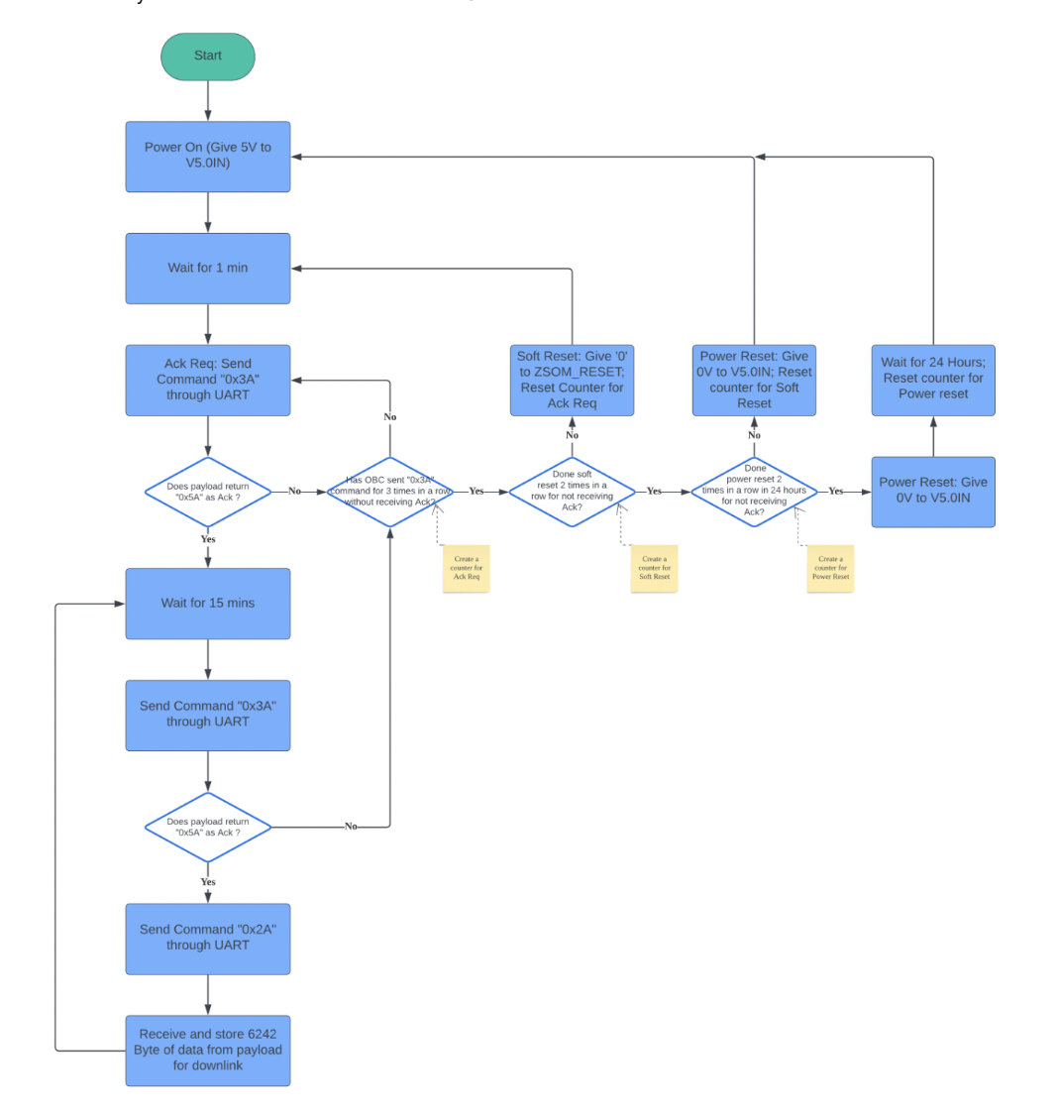

9. Data Handling/Software Hooks/Data Management
- Payload data is queued in a shared OBC file buffer
- File naming convention: YYYYMMDD_payload.bin
- OBC reads and schedules for S-Band transmission
- Fault flag or unusual readings will trigger Iridium beacon
- The data sent out by our payload, when requested every 15 mins, are formatted as table below and the total size will be 6242 bytes. Through this inference the size of the data per day will be around 599232 bytes.
Table 1. Download Data Format
S/N | Data | Bytes
1 | Header (0x2A) | 1
2 | Data | 6240
3 | Tail (0xAA) | 1
 | Total | 6242

Table 2. Data Interpretation of the Downlink Data (per set)
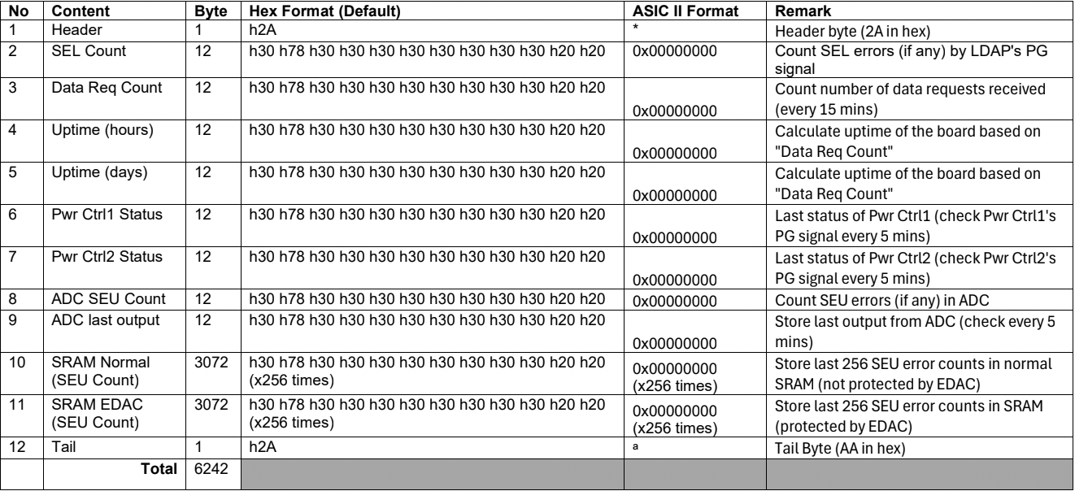
Figure 1. I²C Timing Diagram — Single-Byte Read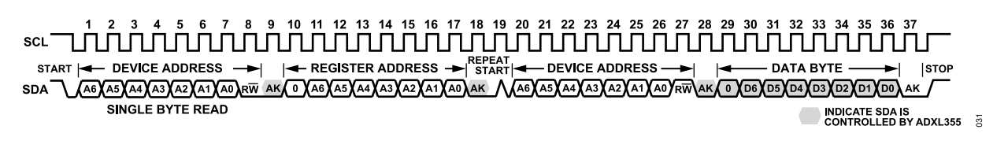
Figure 2. I²C Timing Diagram — Single-Byte Write

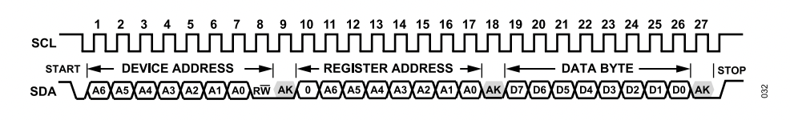
Figure 3. I²C Timing Diagram — Multi-Byte Write

Will add magnetometer data handling for and downlink once the vendor has available information.

10. Verification and Test

Test | Method | Pass Criteria
Electrical Power Test | Supply voltage + current log | 3.3V within 5%; < 300 mA draw
UART Data Transfer | Serial packet logging | No packet loss / corruption over 1hr
Mechanical Fit Check | CAD model + prototype | No interference or blocking
Thermal Profiling | Chamber or passive test | Stays within specified thermal range
RS-422 ↔ UART Link | Serial monitor log | ≥99.9 % valid CRC frames
RILA Power Line  I2C Links | Measure voltage/current  Serial monitor log | 12 V ±0.5 V, <0.5 W peak  ≥99.9 % valid response frames from accelerometers

9. Signature Block and Revision Control

Team | Name | Signature | Date
SDSU | Lujain | __________________ | 2025-11-23
SDSI | [Insert Name] | __________________ | 2025-MM-DD
SJSU | [Insert Name] | __________________ | 2025-MM-DD

Rev. | Date | Description | Editor
A  B  C | 2025-11-17  2025-12-15  2026-03-12 | Initial Draft  1st Revision  2nd Revision | Lujain  Jacob Ogle  Jacob Ogle

